Assessment Questions AOVET Course—Principles of Small Animal Fracture Management - POSTCOURSE
Competency 1 |  | Evaluate small animal patients with fractures
Question 1 |  | Level of difficulty: Easy or difficult |  | Easy (postcourse)
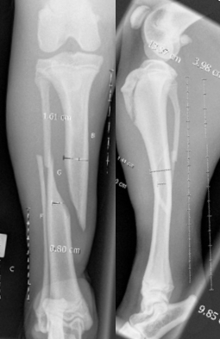 |  |  | These x-rays show a fracture of the tibia. There is a 1-cm long full-thickness skin wound on the medial aspect at the level of the fracture. There are no other injuries.  How do you describe this fracture?
Option A | Type 1 open non-comminuted long oblique mid-diaphyseal tibial fracture and a concurrent fibula fracture
Option B | Closed segmental oblique mid-diaphyseal tibial and fibula fracture
Option C | Closed non-comminuted long oblique mid-diaphyseal tibial fracture and a segmental fibula fracture
Option D | Closed comminuted mid-diaphyseal tibial and fibula fracture
Answer | A
Rationale | Fractures are classified according to the extent of soft tissue injury, the degree of cortical disruption, geometry, location within the bone, degree of displacement, and sometimes the underlying cause. The classifications together provide a full description. Being able to describe, understand and classify fractures is necessary for fracture assessment and treatment decision-making and also for clinical documentation.
Reference(s) | AO Principles of Fracture Management in the Dog and Cat

Competency 1 |  | Evaluate small animal patients with fractures
Question 2 |  | Level of difficulty: |  | Difficult (postcourse)
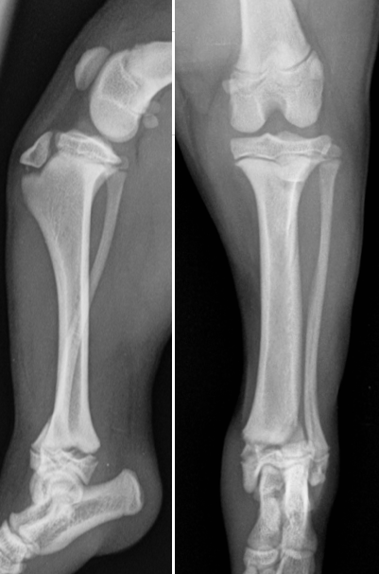 |  |  | These x-rays are from a 17-week-old Jack Russell Terrier, who sustained this distal tibial fracture.  The fracture is closed and extends three quarters of the way across the physis of the tibia then extends up into the tibial metaphysis.  The fracture does not communicate with the articular surface.  Which of the following best describes the fracture?
Option A | Salter-Harris I
Option B | Salter-Harris II
Option C | Salter-Harris III
Option D | Salter-Harris IV
Answer | B
Rationale | A fracture that involves the physis and the metaphysis is a Salter-Harris type II fracture. The metaphyseal fragment is on the lateral side of the tibia.
Reference(s) | Engel, E. and Kneiss, S. (2014) Salter-Harris fractures in dogs and cats considering problems in radiological reports--a retrospective analysis of 245 cases between 1997 and 2012. Berl Munch Tierarztl Wochenschr. 127(1-2):77-83

Competency 2 |  | Select and plan appropriate treatment options
Question 1 |  | Level of difficulty: |  | Easy (postcourse)
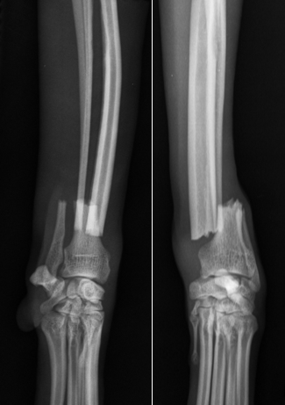 |  |  | These are the x-rays of a 7-year-old, 9-kg Italian greyhound who sustained this closed non-comminuted fracture of the radius jumping off the bed.  This fracture will be repaired with a bone plate of appropriate size. What would be the most appropriate method for applying this bone plate?
Option A | Bone plate applied in compression mode
Option B | Bone plate applied in neutralization mode
Option C | Bone plate applied in neutralization mode with a lag screw
Option D | Bone plate applied in bridging mode
Answer | A
Rationale | This is a simple non-comminuted transverse fracture that is anatomically reconstructable with the potential to achieve full load-sharing. Application of the plate in compression mode will achieve absolute stability and thereby reduce interfragmentary strain. This will create the biomechanical environment for direct bone healing.  Compression plating is indicated for simple (non-comminuted) transverse fractures.  Neutralization plating is indicated for simple (non-comminuted) long oblique and spiral fractures that have been anatomically reconstructed with lag screws.  It is contraindicated to place a lag screw across a transverse fracture.  Bridge plating is indicated for comminuted fractures where anatomic reconstruction and load-sharing cannot be achieved.
Reference(s) | Authors: Peter V Giannoudis, Hans Christoph Pape, Michael Schütz. AO Surgery Reference.

Question 2 |  | Level of difficulty: |  | Difficult (postcourse)
These are the x-rays of a 3-year-old, 8-kg lhasa apso, hit by a car. This 5-piece comminuted tibial fracture will be repaired with a bone plate of appropriate size.

What would be the most appropriate method for applying this bone plate?

Option A | Bone plate applied in compression mode
Option B | Bone plate applied in neutralization mode
Option C | Bone plate applied in neutralization mode with a lag screw
Option D | Bone plate applied in bridging mode
Answer | D
Rationale | The tibia is fractured into 5 pieces. Being so comminuted it is not reconstructable with good biomechanical effect. Attempting to reconstruct this fracture will not achieve load-sharing and instead will devascularize the fragments and place them in a high strain environment which will slow or prevent bone healing.  In non reconstructable comminuted fractures it is preferable to bridge the fracture and not manipulate the bone fragments. This can be done with an “open but do not touch” approach or minimally invasive bridge plate application.  Compression plating is used for simple (non-comminuted) transverse or suitable short oblique fractures. Neutralization plating is used for long oblique and spiral fractures that have been anatomically reconstructed with lag screws and has a plate applied without compression to protect the lag screw repair.
Reference(s) | Perren SM. "Evolution of the internal fixation of long bone fractures." JOURNAL OF BONE AND JOINT SURGERY-BRITISH VOLUME- 84.8 (2002): 1093-1110.

Competency 3 |  | Perform operative and non-operative procedures to treat long bone fractures
Question 1 |  | Level of difficulty: easy |  | Postcourse (Easy)
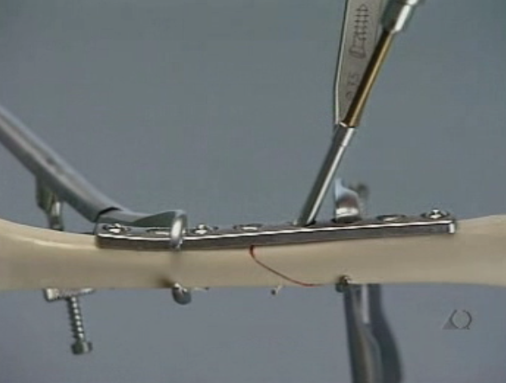 |  |  | This image shows application of an 8-hole DCP plate to an oblique femoral fracture bone model. A lag screw is in the process of being placed across the oblique fracture (a tap can be seen cutting a thread to place the non-self tapping lag screw).  What method of plate application is being performed here?
Option A | Bridge plating
Option B | Compression plating
Option C | Lag plating
Option D | Neutralization plating
Answer | D
Rationale | This plate is being applied as a neutralization plate. Any time that a lag screw is used in an oblique or spiral diaphyseal fracture, the bone plate is applied with all screws in a neutral (non-loaded position) to protect the lag screw repair.  The application of a plate in compression mode across a lag screw repair would be incorrect and could lead to an iatrogenic fracture of the bone around the lag screw.  The application of a plate to span a fracture gap that has not been anatomically reconstructed, as commonly occurs in comminuted fractures, is called bridge plating. There is no such thing as “lag plating”.
Reference(s) | AO principles of Fracture Management in the dog and cat

Competency 3 |  | Perform operative and non-operative procedures to treat long bone fractures
Question 2 |  | Level of difficulty: difficult |  | Difficult (postcourse)
 | Which one of the following statements about cerclage wire is correct?
Option A |  |  | An oblique fracture that is only 3.5 times the bone diameter is not oblique enough to be repaired with cerclage wire.
Option B |  |  | Bending twist cerclage wires to lay flat with the bone reduces the tension within the loop.
Option C |  |  | When placing twist cerclage wire a minimum of 5 full twists should remain after the cerclage twist has been cut to prevent loss of tension.
Option D |  |  | Cerclage wires should be placed a minimum of 2 bone diameters apart.
Answer |  |  | B
Rationale |  |  | The minimum length of an oblique fracture to be suitable for cerclage wiring is to be at least 2x the bone diameter.  The tension in the cerclage wire loop is critical to achieve and maintain effective interfragmentary compression. Bending the twists to lie flat with the bone has been shown to significantly reduce the tension within the cerclage wire loop by between 45% and 90% and so compromises the effectiveness of that wire.  Cerclage wire twists lose significant tension if they are cut shorter than 3 full twists. It is recommended to leave a minimum of 3 full twists after cutting to prevent loss of tension.  Cerclage wires should be spaced 1 bone diameter apart.
Reference(s) |  |  | Wahnert, D et al (2011) Cerclage Handling for Improved Fracture Treatment. A Biomechanical Study on the Twisting Procedure.

Competency 4 |  | Formulate plans for postoperative care including recognition and management of complications
Question 1 |  | Level of difficulty |  | Easy (postcourse)
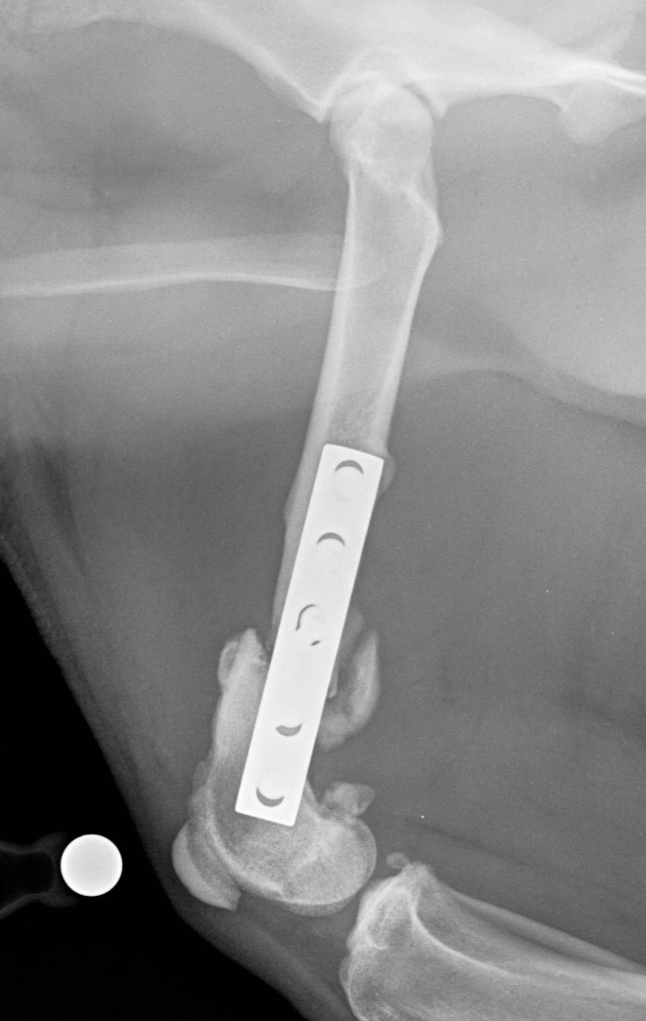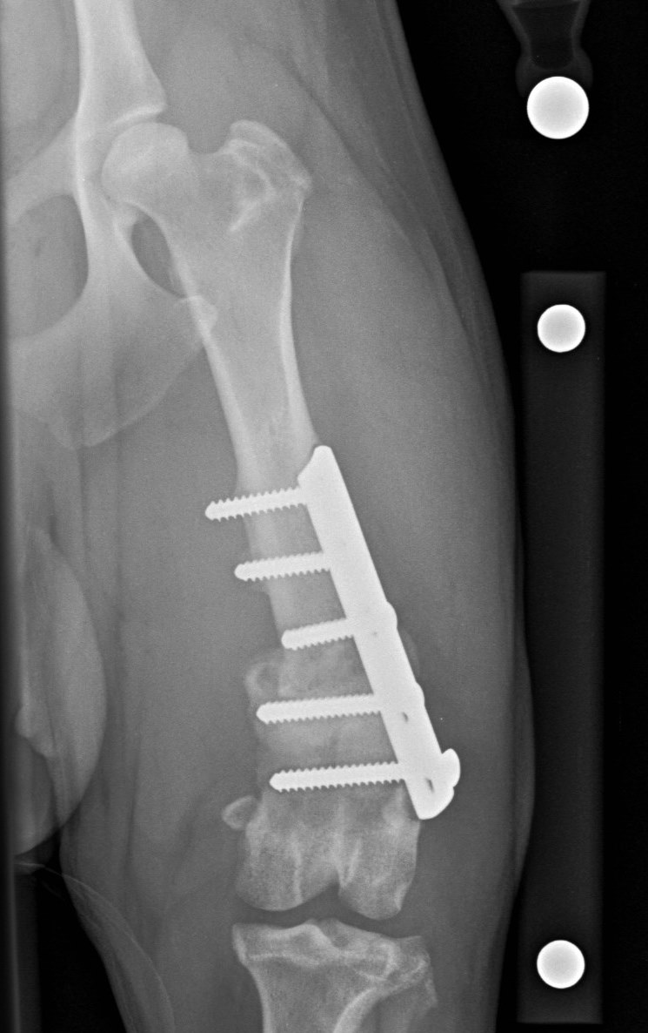 |  |  | These x-rays are from a 1-year-old male neutered Staffordshire bull terrier. This dog sustained a femoral fracture 6 months prior to these x-rays, which was immediately stabilized with a dynamic compression plate.  These current x-rays showed no progression of bone healing since x-rays taken 3 months after surgery.  The two distal screws are backing out of the bone.  The fracture repair is unstable on palpation. The distal screw is loose and the head is no longer in contact with the plate.  Which of the following best describes the current situation?
Option A | Atrophic nonunion
Option B | Delayed union
Option C | Hypertrophic nonunion
Option D | Malunion
Answer | C
Rationale | As this fracture has not healed at 6 months after plating and has no progression of bone healing over the previous 3 months, this can be classified as a nonunion rather than a delayed union, and will not progress to union without further intervention. The mineralized callus apparent on both major bone fragments designates this as a hypertrophic nonunion (ie, one that is still viable) rather than an atrophic nonunion, which would be classified as non-viable.  A delayed union is a fracture that takes longer to heal than anticipated, while a nonunion is defined as a fracture that has failed to heal, and does not show further progression towards healing.  While there is a varus deformity present, as the bone has not united this cannot be classified as a malunion.
Reference(s) | Rovesti GL. Nonunions. In Johnson, A.L., Houlton, J.E. and Vannini, R., 2005. AO principles of fracture management in the dog and cat (pp. 402-409) Georg Thieme Verlag.

Competency 4 |  | Formulate plans for postoperative care including recognition and management of complications
Question 2 |  | Level of difficulty: difficult |  | Difficult (postcourse)
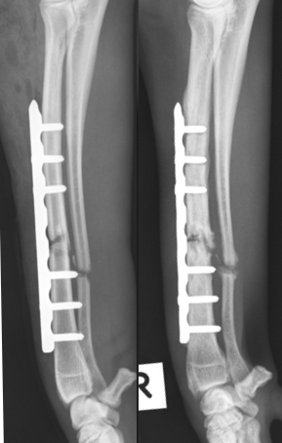 |  |  | These are the x-rays of a dog who had an open radius fracture repaired with a bone plate 4 months ago. In the last week the dog has stopped weight-bearing on this leg.  The left image is from the immediate post-operative x-rays. The right image is 4 months postoperatively and shows a viable nonunion with radiographic evidence consistent with osteomyelitis including lysis of bone around 4 of the screws.  Cytology from a fine needle aspirate identified the presence of infection with a high number of neutrophils and intracellular bacteria.  Instability is apparent on palpation of the fracture.  What one of the following options is the most appropriate course of action?
Option A | Give an 8-week course of antibiotics and then re-x-ray.
Option B | Obtain a sample of tissue from near the fracture for bacterial culture. Give 8 weeks antibiotics based on the results of the bacterial culture and then re-x-ray.
Option C | Remove the bone plate for bacterial culture. Place a cast and give 8 weeks antibiotics based on the results of the bacterial culture.
Option D | Remove the bone plate for bacterial culture. Apply a different bone plate and give 8 weeks antibiotics based on the results of the bacterial culture.
Answer | D
Rationale | Lysis of bone around the screws is consistent with the palpable instability. Replacing this failed implant with something to provide long-term effective stability is necessary as the fracture has not yet healed and the presence of infection means that healing will be prolonged. Infected bone can heal provided that the infection can be effectively controlled with appropriate antibiotics and that the fracture is stable. It is important to identify the bacteria that are causing osteomyelitis and their antibiotic sensitivity pattern as antibiotic resistance in chronic osteomyelitis occurs commonly. Culture of removed implants and a deep tissue sample are the best way of identifying the most appropriate antibiotic.
Reference(s) | Lima ALL, et al (2014) Recommendations for the treatment of osteomyelitis Braz J Infect Dis; 18(5): 526-524.

Competency 5 |  | Critically assess patient outcomes
Question 1 |  | Level of difficulty: Easy |  | Easy (postcourse)
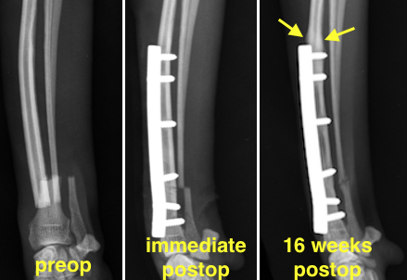 |  |  | These are the preoperative, immediate postoperative, and 16-week postoperative x-rays of a 6 year old Whippet who had a fracture of the distal radius and ulna treated successfully with a bone plate.  The 16-week postoperative x-rays show cortical thickening and sclerosis of the radius at the proximal end of the plate (arrowed). The dog is clinically normal at this time.  What is the most likely cause of this x-ray change at the proximal end of the plate?
Option A | Inflammatory reaction to stainless steel
Option B | Neoplasia
Option C | Osteomyelitis
Option D | Stress remodeling
Answer | D
Rationale | Different stiffness of the bone and plate means that load is concentrated at either end of a plate. This is particularly the case in radius platings in dogs with long bone segments. This plate is relatively large for this dog. Wolff’s law determines that bone will remodel and become stronger in response to increased load. This is a common finding on x-rays after placement of a bone plate on a fractured radius.  The absence of clinical signs and of bone destruction means that osteomyelitis and neoplasia are highly unlikely.  Implants made of 316L surgical stainless steel are rarely associated with significant inflammatory reactions.
Reference(s) | Uhthoff, H.K., Poitras, P., Backman, D.S. (2006) Internal plate fixation of fractures: short history and recent developments. J Orthop Sci. 2006 Mar; 11(2): 118–126.

Competency 5 |  | Critically assess patient outcomes
Question |  | Level of difficulty: difficult |  | Difficult (postcourse)
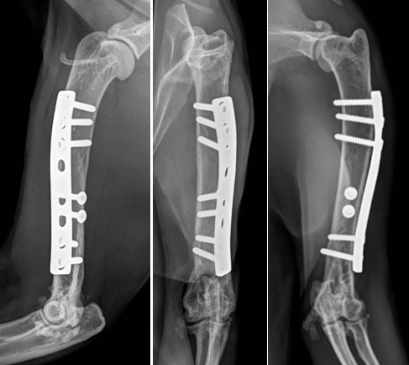 |  |  | These are the x-rays of a 13 year-old cat, who 3 years previously had a type 1 open humeral fracture repaired with lag screws and a neutralization plate.  The cat had healed and was clinically normal until 3 weeks ago when he began limping on this leg. There is a purulent discharge coming from a sinus over the lateral aspect of the mid-humerus.  Multiple radiolucencies are present in the humeral diaphysis.  (note: This cat also has chronic elbow osteoarthritis that is not associated with the discharging sinus).  What one of the following statements is correct?
Option A | The infection may be associated with a cryptic implant infection as this had been an open fracture.
Option B | The infection is unlikely to be related to the implant as it has been 3 years since the fracture repair.
Option C | Culture of the pus from the discharging sinus and treatment with appropriate antibiotics based on the culture is recommended.
Option D | Bone plates are contraindicated in managing open fractures.
Answer | A
Rationale | Some bacteria have the ability to adhere to implants and produce a mucopolysaccharide “slime” layer that protects them from the immune system and from antibiotics. This is known as a cryptic infection. Osteomyelitis can become a clinical problem often years later if this has occurred.  Bacterial culture from a discharging sinus is likely to grow skin commensals and so not be representative of underlying osteomyelitis.  Bone plates are not contraindicated for use in open fractures.
Reference | Zimmerli W and Sendi P: Pathogenesis of implant-associated infection. Seminars in Immunopathology, 05/2011, Volume 33, Issue 3.

