Patient positioning–Key elements for success

Time: 60 to 90 minutes (depends on the available time)
Faculty:
Room:

Introduction text:
Patient positioning is a key step to success in fracture care especially for reduction, use of imaging (c-arm) and fixation. This is something that varies depending on the table we use (fracture table vs. conventional radiolucent table) and the reduction and fixation technique we are planning to use. On this activity we will show tips and tricks from faculties from different parts of the world for patient positioning and C-arm imaging in upper and lower extremity fractures.

Program

Time | AGENDA ITEM
14:00 – 14:05 | Introduction
14:05 – 15:20 | Demonstration of different patient positions to treat upper and lower extremity fractures
15:20 – 15:30 | Summary and take home message

Learning Outcomes
- Describe different patient positions (set-up of the operating room) used in fracture surgery (upper extremity, lower extremity, pelvis)

Faculty Roles
- Moderator: organize the set-up using the elements described in the section elements needed. When he is moderating he has to explain the procedure he is performing and the patient position, C-arm, and screens as well as anesthesia team position for that specific surgical procedure.
- Patient: a faculty to lay down as a patient
- Anesthesiologist: a faculty who can play this role so he can sit down where we need anesthesia team to be during the surgery
- Screens of the C-arm: a faculty to hold a piece of paper simulating the C-arm screens
- X-ray technician: a faculty to be the x-ray technician and manage the mockup C-arm

These roles can rotate among the faculty so each faculty can show his/her preferred patient position to do a surgical procedure.

Elements needed
- Mockup C-arm
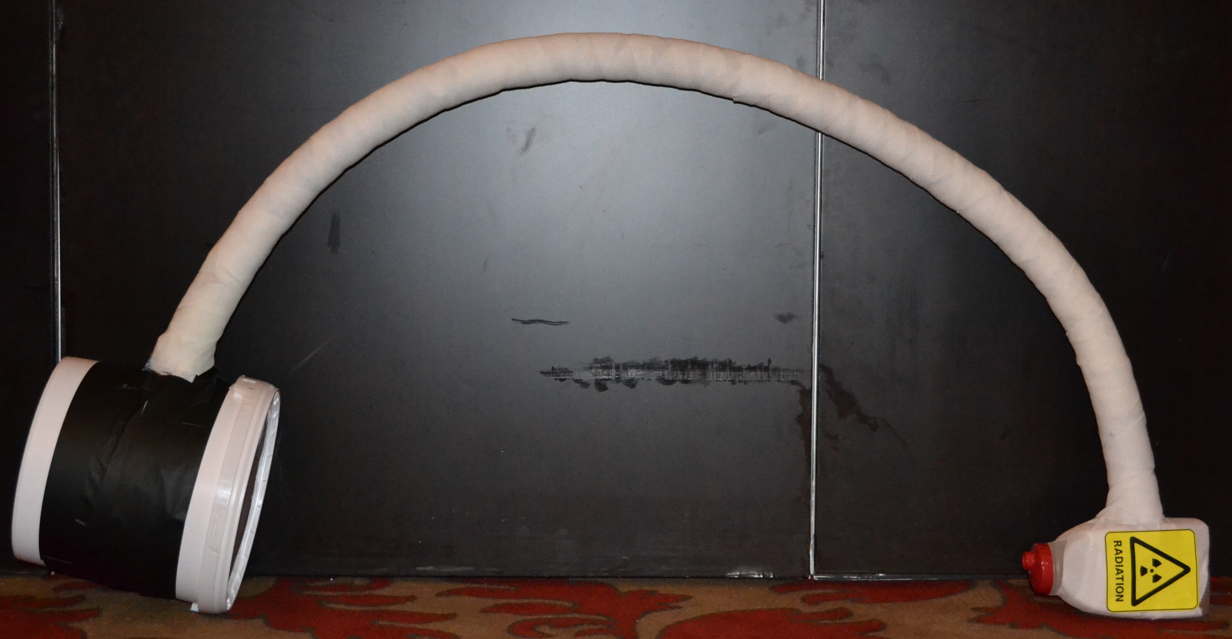
- Long table to accommodate the patient (in Davos we use 2 tables side by side)
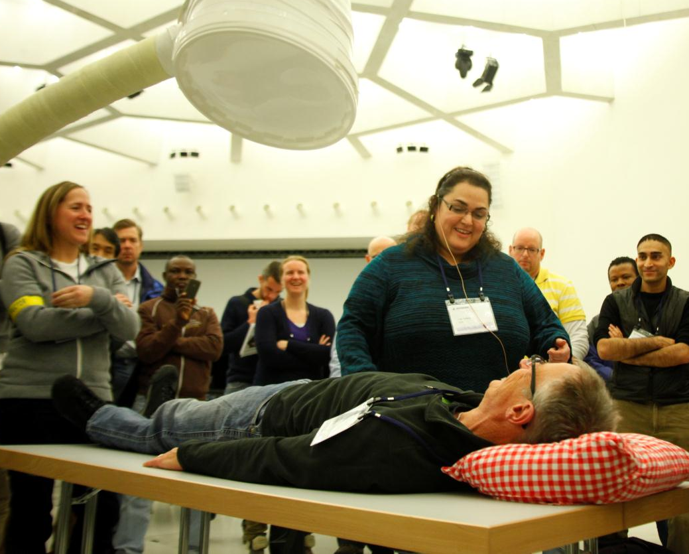

- Cushions (4 to 6) and some blankets (sheets) to use as bumps to position the patient
- Fake C-arm screens
- A chair for the anesthesiology

How to run it
Decide with your fellow faculties and course chairman which surgical procedures and positions you are going to demonstrate and the order to do it. 5-6 operations are recommended.

Don't try and teach all the positions on the list below. More is less; if you try to cover more than about 5-6 operations there is a risk that no one will remember anything other than that the session was fun.

Tailor the session to the audience. Basic Principles course participants are much less experienced than Advanced Principles participants and may need a more detailed explanation and more basic positioning.

Upper extremity
- Proximal humeral fractures: beach chair and supine on a radiolucent table, using a nail or a plate
- Humeral shaft fractures:
  - Plating anterior and anterolateral supine (ORIF and MIPO) plating posterior (lateral decubitus and prone)
  - Nailing antegrade and retrograde
- Distal humeral fractures: with and without olecranon osteotomy

Lower extremity:
- Proximal femur fractures: regular radiolucent table (using plates, sliding hip screws and nails) and / or using a fracture table (different positions: scissors, well leg in a support and both legs in traction and well leg in abduction)
- Femoral shaft fracture on a regular radiolucent table: nailing supine and lateral, plating supine. Discuss use of a fracture table.
- Distal femur and proximal tibia (knee injuries)
- Tibial shaft: radiolucent table, traction table hanging leg
- Distal tibia and ankle
- Calcaneus

Pelvis
- Sacroiliac screws
- External fixator

The patient positioning workshop must be very interactive and quite lighthearted and amusing while still having important learning points.

Every position is introduced by a moderator: The moderator explains the procedure he is performing and the patient position, C-arm, and screens as well as anesthesia team position for that specific surgical procedure.

Use the strengths of the faculty who are there. Almost always there will be a faculty member or two who use a different technique for doing one procedure. Showing participants there is more than one "right way" is important.

Encourage audience participation. More experienced audience members may also have a different way of doing something and should be encouraged to share and demonstrate it.

C-arm mockup construction: The main ingredients are fiberglass plaster casting material 3-4 rolls to hold everything together and give it rigidity) one or two bendy foam swimming pool exercising "sausages" (the curved arm of the c arm) with a large plastic tub about 30 cm in diameter (big pathology specimens pots from theatres work well as do empty tubs in which garden fertilizer is sold) at one end and a 2 or 4 liter empty plastic milk container at the other.

Authors of this document: Rodrigo Pesantez, Matthew Porteous, Wa'el Taha.

