Storyboard: Giving a lecture

Struktur:

1. Begin
2. Welcome
   1. Giving a lecture
   2. Learning Outcomes
3. Exercises
   1. Lectures: The good, the bad, and the ugly
   2. Getting started (...the bad and the ugly)
   3. Content and visual aids
   4. Delivery, attitude, and closure
   5. Feedback: Bad lecture
   6. Feedback: Bad lecture
   7. The good: a great start to a lecture
   8. Getting the message across
   9. Visual aids
   10. The "take-home" message
   11. Feedback: Good lecture
   12. Feedback: Good lecture
4. Knowledge check

4.1 Question 1—Defining a lecture

4.2 Question 2—The six-step preparation framework

4.3 Question 3—Language and communication

4.4 Question 4—Effective handouts

4.5 Question 5—Using PowerPoint

1. Summary

5.1 Giving a lecture – Key points and checklists

1. Begin

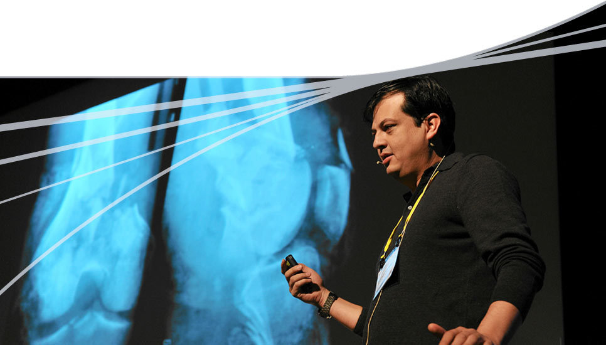**eLearning**

**Giving a lecture**

1. Welcome
   1. Giving a lecture

**Giving a lecture**

Welcome to the online component for module 2—Giving a lecture

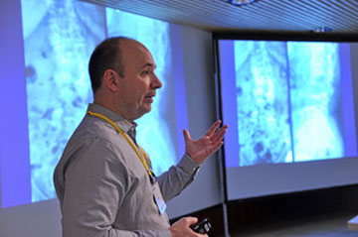

This eLearning session is divided into a number of sections:

* Exercises on giving a lecture
* Knowledge check
* Summary
  1. Learning outcomes

**Learning Outcomes**

After studying this module, you should be able to:

* Describe the educational value, advantages, and disadvantages of lectures
* Evaluate a lecture in terms of good and bad practice
* Recognize that organized planning is important for an effective lecture
* Prepare a lecture according to AO's 7 principles of education
* Apply best practices when developing presentation slides (eg, amount and depth of content, fonts, animation)

1. Exercises

3.1 Lectures: The good, the bad, and the ugly

**Lectures: The good, the bad, and the ugly**

This section of the exercise will give you the opportunity to evaluate a lecture and identify:

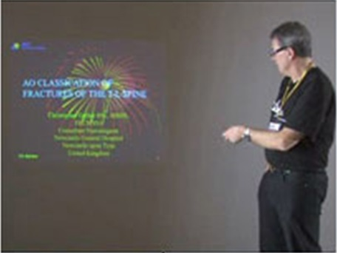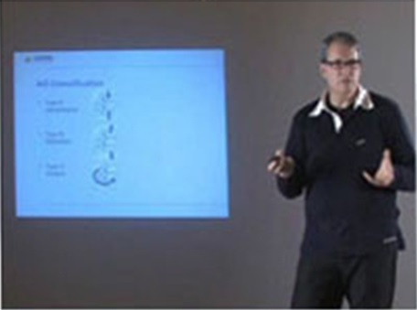

Evaluation and feedback

**The bad**

identifying

common pitfalls

**The good**

identifying good

practice

**1) Common pitfalls to avoid**

**2) Good practice** that you can incorporate into your lectures. There are normally four topic areas that we can use when evaluating a lecture:

* Visual aids
* Content
* Communication
* Attitude

3.2 Getting started (...the bad and the ugly)

**Getting started (...the bad and the ugly)**



The start of a lecture is critical for getting the attention of the learners and setting the scene for the learning.

Which of these common mistakes are evident in the video?

Facing away from the audience

Mumbling

Reading from a "script"

Emphasis on "self" rather than on learners

Long rambling opening delivery

Your answer is not correct or only partly correct.

Please try again or press the Solution button.

Incorrect

A good start to a lecture usually requires:

* Preparation and practice
* An interesting and relevant start
* An evident structure
* Positive body language
* Actively involving the learners

Correct

A good start to a lecture usually requires:

* Preparation and practice
* An interesting and relevant start
* An evident structure
* Positive body language
* Actively involving the learners

Solution

3.3 Content and visual aids

**Content and visual aids**



The lecturer wants the audience to learn about the AO Classification of fractures—is he achieving this through his explanation and visual aids?

Select two examples of good practice that he has used in some of his lecture.

Using lower case text

Using lists and bullet points

Consistent format

One basic point per visual

Using large fonts

Your answer is not correct or only partly correct.

Please try again or press the Solution button.

Incorrect

Good preparation

Clear explanations

Common pitfalls that need to be avoided include:

* Lack of preparation
* Poor visual aids
* Unclear explanations and a lack of good examples

PowerPoint slides should be neat and well designed—use bullets, images, and large lower case text to emphasize one key point per slide.

**Reference:** "Giving a lecture" Booklet p11

Correct

Common pitfalls that need to be avoided include:

* Lack of preparation
* Poor visual aids
* Unclear explanations and a lack of good examples

PowerPoint slides should be neat and well designed—use bullets, images, and large lower case text to emphasize one key point per slide.

**Reference:** "Giving a lecture" Booklet p11

Solution

3.4 Delivery, attitude, and closure

**Delivery, attitude, and closure**

Good presentation skills are important to make sure that learners are engaged and understand the information you are trying to communicate to them.

Which of these features of the lecturer’s delivery would you recommend that he works on improving?

Body language

Explaining and summarizing

Pace—speed of speech

Eye contact

Creating closure

Your answer is not correct or only partly correct.

Please try again or press the Solution button.

Incorrect

Four useful points to remember are:

* Delivery: People learn most from how you are, not what you say
* Attitude: Focus on the learners and show appropriate behavior
* Reinforce: Chunk information and highlight/summarize key points
* Closure: What learners hear last, they will remember

**...and always turn your mobile phone off!**

**Reference:** "Giving a lecture" booklet p6, 7

Correct

Four useful points to remember are:

* Delivery: People learn most from how you are, not what you say
* Attitude: Focus on the learners and show appropriate behavior
* Reinforce: Chunk information and highlight/summarize key points
* Closure: What learners hear last, they will remember

**...and always turn your mobile phone off!**

**Reference:** "Giving a lecture" booklet p6, 7

Solution

3.5 Feedback: Bad lecture

**Feedback: Bad lecture**

**Font**

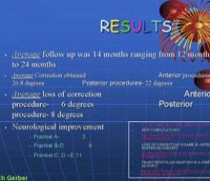 *Start the video for feedback*



**Eye contact, body language**

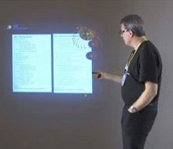 *Start the video for feedback*



3.6 Feedback: Bad lecture

**Feedback: Bad lecture**

**Final slide, "take-home" message, summary**

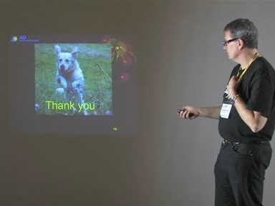 *Start the video for feedback*



**Microphone**

During the lecture, please remove your name badge as we have found in the past that the lanyard interferes with the microphone and this can be heard by participants. Once the lecture is over, please refasten your name badge.

 *Start the video for feedback*



3.7 The good: a great start to a lecture

**The good: a great start to a lecture**



*Start the video and select the correct answer.*

A lecturer only has between 7 and 20 seconds to engage the learners before they start to lose concentration.

What does the lecturer use to grab the audience’s attention?

A quick quiz

An interesting case study

An energetic demonstration

A funny joke

Your answer is not correct.

Please try again or press the Solution button.

Incorrect

A good lecture starts by:

* Immediate focus on topic
* Excellent case—gets learners' attention from the start
* Early active involvement of the learners
* Getting and responding to learner feedback
* Good supporting images
* Good supporting body language

**Reference:** "Giving a lecture" booklet p6

Correct

A good lecture starts by:

* Immediate focus on topic
* Excellent case—gets learners' attention from the start
* Early active involvement of the learners
* Getting and responding to learner feedback
* Good supporting images
* Good supporting body language

**Reference:** "Giving a lecture" booklet p6

Solution

3.8 Getting the message across

**Getting the message across**



*Start the video and select the correct answer.*

It is very important to present and explain the key learning points in a way that will help learners to learn. Providing the opportunity for reflection is an important feature of the learning process.

How does the lecturer give learners an opportunity for reflection in this clip?

By "chunking" information and summarizing

By pausing between slides, thoughts, and ideas

By using the laser pointer to pick out important points

By drawing clear conclusions

Your answer is not correct.

Please try again or press the Solution button.

Incorrect

All of the options here do help learners to take in and remember information better, but building reflection into your delivery requires giving **time** for learners to reflect and store away information.

**A steady pace and pauses between slides provide time and opportunity for reflection.**

Correct

All of the options here do help learners to take in and remember information better, but building reflection into your delivery requires giving **time** for learners to reflect and store away information.

**A steady pace and pauses between slides provide time and opportunity for reflection.**

Solution

3.9 Visual aids

**Visual aids**

Well designed slides that are easy to read and present learning points effectively are a great way to support learning.

Which of these options reflect good practice in slide design?

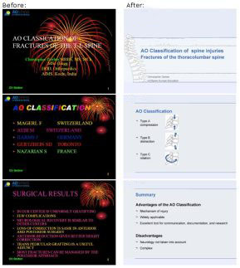Low contrast color scheme, lower-case letters, serif font (eg, Times New Roman)

Low contrast color scheme, lower-case letters, sans serif font (eg, Arial, Verdana)

High contrast color scheme, upper-case letters, sans serif font

High contrast color scheme, lower-case letters, sans serif font

Your answer is not correct.

Please try again or press the Solution button.

Incorrect

Good consistent slide design:

* Simple and high contrast color scheme
* Sans serif font, not Times New Roman
* Lower-case, not upper-case letters
* No animation
* Good quality supporting images
* Not more than 6 lines of 6 words per slide

**Reference:** "Giving a lecture" booklet p11

Correct

Good consistent slide design:

* Simple and high contrast color scheme
* Sans serif font, not Times New Roman
* Lower-case, not upper-case letters
* No animation
* Good quality supporting images
* Not more than 6 lines of 6 words per slide

**Reference:** "Giving a lecture" booklet p11

Solution

3.10 The "take-home" message

**The "take-home" message**



*Start the video and then select the correct answers.*

How a lecture is delivered (body language) and how it ends will often determine what learners remember.

What does the lecturer do in this example to deliver a strong "take-home" message?

He uses positive and open gestures

He uses a strong case-study

He tells a memorable joke

He invites questions and provides feedback

He summarizes the main points

Your answer is not correct.

Please try again or press the Solution button.

Incorrect

Good delivery includes:

* Poise and eye contact
* A strong start and end
* Clear presentation—explanations and slides
* Engaging the learners
* Inviting questions
* Providing feedback

**Reference:** "Giving a lecture" booklet p7

Correct

Good delivery includes:

* Poise and eye contact
* A strong start and end
* Clear presentation—explanations and slides
* Engaging the learners
* Inviting questions
* Providing feedback

**Reference:** "Giving a lecture" booklet p7

Solution

3.11 Feedback: Good lecture

**Feedback: Good lecture**

**Structure**

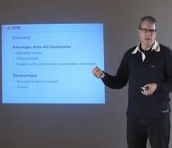 *Start the video for feedback*



**Delivery**

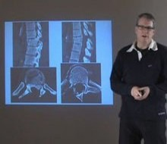 *Start the video for feedback*



 3.12 Feedback: Good lecture

**Feedback: Good lecture**

**Hand gestures**



*Start the videos for feedback*

**Mhs.., ahs...**

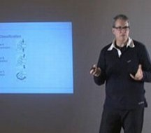 *Start the videos for feedback*



1. Knowledge check

4.1 Question 1—Defining a lecture

**Question 1—Defining a lecture**

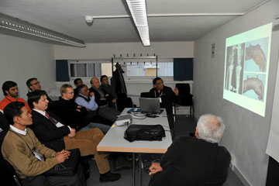Which one of these options correctly completes this definition?

A lecture is a more or less continuous exposition by a speaker who wants:

To transmit information to the audience

To get the audience to be actively involved

Your answer is not correct.

Please try again or press the Solution button.

Incorrect

To help the audience learn something

To change the audience's attitude or behaviour

This is the correct answer with the key word being *'****learn****'*.

We can apply the "7 principles of education" covered in Module 1, to help ensure that our lectures enable learning and are:

* Motivates to learn
* Relevant
* Interactive
* Leads to verifiable outcomes
* Based on needs
* Promotes reflection
* Provides feedback

**Reference:** "Giving a lecture" booklet p3

Correct

This is the correct answer with the key word being *'****learn****'*.

We can apply the "7 principles of education" covered in Module 1, to help ensure that our lectures enable learning and are:

* Motivates to learn
* Relevant
* Interactive
* Leads to verifiable outcomes
* Based on needs
* Promotes reflection
* Provides feedback

**Reference:** "Giving a lecture" booklet p3

Solution

4.2 Question 2—The six-step preparation framework

**Question 2—The six-step preparation framework**

The six-step preparation framework helps us to plan effective lectures. Select the correct labels to complete this diagram.

*Click on the arrow on each box and select an option. Click OK when you have finished.*

Select the correct option ...

Spice it up and edit it

Create closure

Practice and refine

Write a script

Add more material

**Set learning outcomes**



Create closure



**Design a structure**



Spice it up and edit it



Your answer is incorrect.

Please try again or press the Solution button.

Incorrect

**Prepare resources**

Practice and refine



This six-step preparation will help avoid common pitfalls such as:

* Trying to cover too much material
* Failing to prepare adequately
* Being perceived as disorganized or unclear
* Encouraging student passivity
* Ignoring student feedback
* Failing to use good examples
* Displaying distracting or poor delivery

**Reference:** "Giving a lecture" booklet p7

Correct

This six-step preparation will help avoid common pitfalls such as:

* Trying to cover too much material
* Failing to prepare adequately
* Being perceived as disorganized or unclear
* Encouraging student passivity
* Ignoring student feedback
* Failing to use good examples
* Displaying distracting or poor delivery

**Reference:** "Giving a lecture" booklet p7

Solution

4.3 Question 3—Language and communication

**Question 3—Language and communication**

Albert Mehrabian calculated how important a speaker’s language or body language is in relation to getting their message across. Complete this table by dragging each option to the correct place then click OK.

7% of our understanding comes from **Words we hear**

38% of our understanding comes from **Tone of voice**

55% of our understanding comes from **Body language**

Your answer is not correct.

Please try again. For the correct answer select the Solution button.

Incorrect

These are Albert Mehrabian's results showing that up to 55% of our understanding can be affected by nonverbal cues. Poor or distracting body language does need to be avoided:

* Posture: stand, relax, face-forward
* Communicate: with your whole body
* Gestures: be spontaneous, animated, and reinforce learning points

**Reference:** "Giving a lecture" booklet p8

Correct

These are Albert Mehrabian's results showing that up to 55% of our understanding can be affected by nonverbal cues. Poor or distracting body language does need to be avoided:

* Posture: stand, relax, face-forward
* Communicate: with your whole body
* Gestures: be spontaneous, animated, and reinforce learning points

**Reference:** "Giving a lecture" booklet p8

Solution

4.4 Question 4—Effective handouts

**Question 4—Effective handouts**

Handouts can be very useful resources, so when designing a handout, which of the following considerations should you take? Select all of the answers you think are correct and then click OK.



Include everything that you are going to say in your lecture

Include main points as text (no graphics)

Include plenty of "white space" for additional notes

Include well documented references rather than pages of text

Your answer is not correct or only partly correct.

Please try again or press the Solution button.

Incorrect

Handout design considerations:

* **Include plenty of white space**—for learner notes
* **Clearly structure the topic**—highlighting headings and main points
* **Include key graphics**—these are often difficult to copy down
* **Keep length to a minimum**—signpost references instead

**Reference:** "Giving a lecture" booklet p10

Correct

Handout design considerations:

* **Include plenty of white space**—for learner notes
* **Clearly structure the topic**—highlighting headings and main points
* **Include key graphics**—these are often difficult to copy down
* **Keep length to a minimum**—signpost references instead

**Reference:** "Giving a lecture" booklet p10

Solution

4.5 Question 5—Using PowerPoint

**Question 5—Using PowerPoint**

Can you identify which of these options are "Do's" and which are "Don'ts" when you are creating an effective PowerPoint presentation?

*Click the correct column for each of these terms, then click OK.*

|  |  |  |
| --- | --- | --- |
|  | **Do's** | **Don'ts** |
| Use upper case text | **ο** | **ο** |
| Use lists and bullet points | **ο** | **ο** |
| Use no more than 6 lines of 6 words per slide | **ο** | **ο** |
| Use full sentences | **ο** | **ο** |
| Use personal interest images to fill spaces | **ο** | **ο** |
| Use a spell-checker | **ο** | **ο** |

Your answer is not correct or only partly correct.

Please try again or press the Solution button.

Incorrect

Good visual aids and images really help to get your message across. Also remember the handy hints from the "Lecturer—Presentation Skills" mnemonic:

**L—Language**

**E—Eye contact**

**C—Comedy**

**T—Talking**

**U—Unexpected**

**R—Rehearse**

**E—Engage**

**R—Respond**

Correct

Good visual aids and images really help to get your message across. Also remember the handy hints from the "Lecturer—Presentation Skills" mnemonic:

**L—Language**

**E—Eye contact**

**C—Comedy**

**T—Talking**

**U—Unexpected**

**R—Rehearse**

**E—Engage**

**R—Respond**

Solution

1. Summary

5.1 Giving a lecture – Key points and checklists

**Giving a lecture – Key points and checklists**

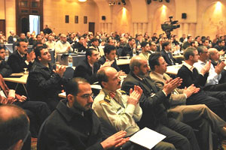**Planning and preparation—a six-step framework**

* Set learning outcomes
* Create closure
* Design a structure
* Spice it up and edit it
* Prepare resources
* Practice and refine

**Presentation skills—LECTURER**

* **L**anguage—communication with your whole body
* **E**ye contact—maintain eye contact throughout
* **C**omedy—avoid inappropriate humour
* **T**alking—keep it slow, clear, and simple
* **U**nexpected—spice it up to aid memory
* **R**ehearse—practice makes perfect
* **E**ngage—get your audience's attention (and keep it)
* **R**espond—don't ignore audience reactions or confusion

**Checklist - Lecture planning and preparation**

**Checklist - Lecturer presentation skills**

**Checklist - PowerPont presentation**