Storyboard: Facilitating small group discussions

Struktur:

1. Begin
2. Welcome
   1. Facilitating small group discussions
   2. Learning outcomes
3. Exercises
   1. Facilitating small group discussions - the role of the case study
   2. How NOT to get started
   3. Presenting the case study
   4. Facilitating discussin about the case study
   5. Questioning skills
   6. Responding - Bad practice
   7. Redirecting and progressing the discussion
   8. Translating what is learned into practice
   9. Closure
4. Knowledge check

4.1 Question 1— Characteristics of effective discussions

4.2 Question 2— Planning a discussion group

4.3 Question 3— Language and communication

4.4 Question 4— Case study preparation

4.5 Question 5— Promoting discussion

4.6 Question 6— Discussion session closure

4.7 Question 7— Discussion as a learning tool

1. Summary

5.1 Facilitating small group discussions—Key points and checklists

1. Begin

**eLearning** Begin

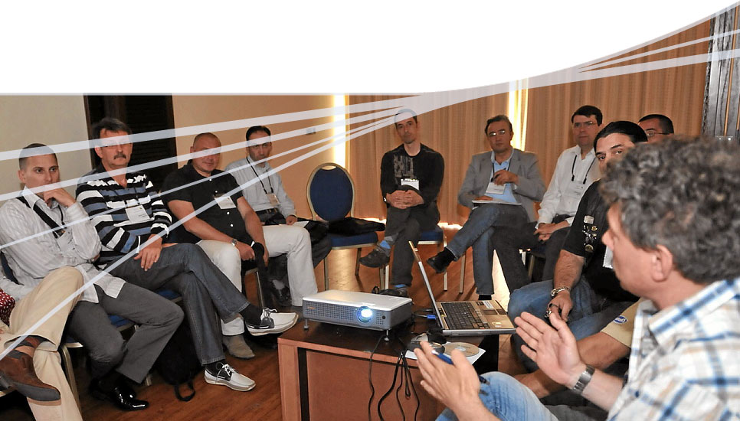**Facilitating small group discussions**

1. Welcome
   1. FacilitatFacilitating small group discussions

**Facilitating small group discussions**

Welcome to the online component for module 4—Facilitating small group discussions

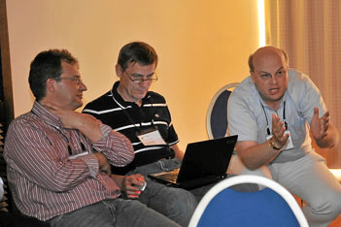This eLearning session is divided into a number of sections:

* Exercises on how to use case studies in group discussions
* Knowledge check
* Summary
  1. Learning outcomes

**Learning outcomes**

After studying this module, you should be able to:

* 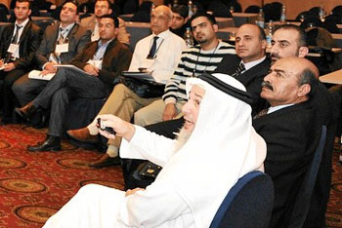Explain the role of small group discussions in learning and in AO courses
* Identify the characteristics of a discussion session
* Define the role of the discussion facilitator
* Formulate a structure for planning and facilitating a discussion
* Select and present case studies
* Set up the environment
* Identify a variety of techniques to stimulate discussion
* Describe how to handle participants who over or under contribute
* Identify and clarify key learning points through the discussion
* Summarize learning to close a discussion

1. Exercises

3.1 Facilitating group discussions - the role of the case study

**Facilitating small group discussions—the role of the case study**

This section of the program will allow you to explore a series of video clips and interactive exercises to illustrate good, bad, and best practice when facilitating a small discussion group.

Using case studies:

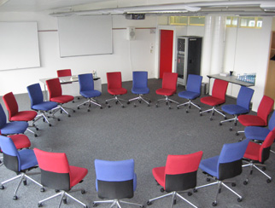**1) The set:**

preparation, background, and expectations

**2) Dialogue:**

questioning, responding, and redirecting

**3) Closure:**

summarizing key discussion points

3.2 How NOT to get started

**How NOT to get started**



The start of a discussion session should set the scene for the learning and introduce the case study.

Which of these best practice items has the facilitator failed to do in this video clip?

Prepare

Use a suitable case study

Set roles and expectations

Arrange the seating

Explain the session structure/objectives

Your answer is not correct or only partly correct.

Please try again or press the Solution button.

Incorrect

A good start to an effective discussion session requires:

* Preparation and practice
* Setting up the environment
* Setting roles, expectations, and objectives
* The use of a suitable case study

**Reference:** "Facilitating small group discussions" booklet p4, 5

Correct

A good start to an effective discussion session requires:

* Preparation and practice
* Setting up the environment
* Setting roles, expectations, and objectives
* The use of a suitable case study

**Reference:** "Facilitating small group discussions" booklet p4, 5

Solution

3.3 Presenting the case study

**Presenting the case study**



Here is an example of a good start to a discussion session where the facilitator is presenting the essential case study background to start the discussion.

What else could he have included at this stage?

A description of the patient

The circumstances of the injury

X-rays

Other supporting evidence

An initial question to get the discussion started

Your answer is not correct.

Please try again or press the Solution button.

Incorrect

The facilitator has covered all of the essential information to start the discussion, including a description of the patient, the circumstances of the injury, and x-rays. He could also have used more supporting evidence if it was available.

The facilitator also had a good straightforward opening question to get the discussion started.

**Reference:** "Facilitating small group discussions" booklet p5

Correct

The facilitator has covered all of the essential information to start the discussion, including a description of the patient, the circumstances of the injury, and x-rays. He could also have used more supporting evidence if it was available.

The facilitator also had a good straightforward opening question to get the discussion started.

**Reference:** "Facilitating small group discussions" booklet p5

Solution

3.4 Facilitating discussion about the case study

**Facilitating discussion about the case study**



Discussing the case study should help learners to attain a deeper understanding of the material covered in earlier lectures and practical sessions. This will help them to identify and translate what they need to change in practice.

What is the main way that the facilitator can shape and guide the discussion?

Clear expectations

Keeping track of the time

Asking good questions

Pace - speed of speech

Your answer is not correct.

Please try again or press the Solution button.

Incorrect

After setting up the discussion, we move to the dialogue. Here the main task is to shape and guide the discussion and to keep it moving. The main way to do this is by asking really good questions that move the discussion forward:

* Get people involved and contributing
* Progress discussion and keep to time

**Reference:** "Facilitating small group discussions" booklet p6

Correct

After setting up the discussion, we move to the dialogue. Here the main task is to shape and guide the discussion and to keep it moving. The main way to do this is by asking really good questions that move the discussion forward:

* Get people involved and contributing
* Progress discussion and keep to time

**Reference:** "Facilitating small group discussions" booklet p6

Solution

3.5 Questioning skills

**Questioning skills**

Bringing learners into the discussion often involves the use of questions. The two main types of questions we use are open or closed.

Which of these video clips is an example of an open question and which is closed?



Open question

Closed question

Select the correct label

Open question

Closed question

Select the correct label

Open question

Closed question

Your answer is incorrect.

Please try again or press the Solution button.

Incorrect

*Closed questions (eg, "What term do we use ...?")*

Good for checking understanding and emphasizing key learning points or terminology

*Open questions (eg, "What other explanations could there be...?")*

Good for promoting discussion—expanding scope and ideas, encouraging reflection and thought

**Reference:** "Facilitating small group discussions" booklet p6

Correct

*Closed questions (eg, "What term do we use ...?")*

Good for checking understanding and emphasizing key learning points or terminology

*Open questions (eg, "What other explanations could there be...?")*

Good for promoting discussion—expanding scope and ideas, encouraging reflection and thought

**Reference:** "Facilitating small group discussions" booklet p6

Solution

3.6 Responding - Bad practice

**Responding—Bad practice**



During a discussion the way the facilitator responds to participants contributions is essential. How could the facilitator have responded more effectively to this contribution?

By opening the discussion to the group

By using his own expert opinion

By being better prepared

By being more forceful in the way he disagreed

Your answer is not correct.

Please try again or press the Solution button.

Incorrect

Case studies allow a safe environment to explore different opinions. All contributions should be treated respectfully. As a facilitator it is not appropriate to close down the discussion by firmly disagreeing with participants or by setting yourself up as the main "expert". It is much more valuable to respond positively and to bring in contributions from other participants to explore different approaches.

**Reference:** "Facilitating small group discussions" booklet p6

Correct

Case studies allow a safe environment to explore different opinions. All contributions should be treated respectfully. As a facilitator it is not appropriate to close down the discussion by firmly disagreeing with participants or by setting yourself up as the main "expert". It is much more valuable to respond positively and to bring in contributions from other participants to explore different approaches.

**Reference:** "Facilitating small group discussions" booklet p6

Solution

3.7 Redirecting and progressing the discussion

**Redirecting and progressing the discussion**



During the discussion it is important to encourage participation and to keep the discussion moving.

What techniques does the facilitator in this clip use to do this?

Ensure that one person speaks at a time

Pick on quiet participants to contribute

Asking suitable questions

Probing for more depth/evidence

Providing expert opinion

Giving positive feedback

Your answer is not correct or only partly correct.

Please try again or press the Solution button.

Incorrect

* Ask the right questions to the group (rather than picking one participant who may not be ready)
* Clarify key points related to the case study by asking more probing questions to the contributor (rather than adding your own expert opinion)
* Encourage participants to bring in theory and evidence from the case study—one at a time
* Redirect questions to other participants to encourage participation

Correct

* Ask the right questions to the group (rather than picking one participant who may not be ready)
* Clarify key points related to the case study by asking more probing questions to the contributor (rather than adding your own expert opinion)
* Encourage participants to bring in theory and evidence from the case study—one at a time
* Redirect questions to other participants to encourage participation

Solution

3.8 Translating what is learned into practice

**Translating what is learned into practice**



The aim of any AO course is to help participants learn new skills and to translate new knowledge and skills into practice. Which of these key learning principles is predominantly provided during discussion groups that helps this process to occur?

Learners need to practice their psychomotor skills

Learners need to have a range of activities suitable for visual, kinaesthetic, and auditory preferences

Learners need to be actively involved with their learning

Learners need to reflect on what they have learned

Your answer is not correct.

Please try again or press the Solution button.

Incorrect

All of the statements above are correct. However learners are able to reflect on what they have learned—to mentally digest the new theories and practices in discussion groups.

**Reference:** "Facilitating small group discussions" booklet p3

Correct

All of the statements above are correct. However learners are able to reflect on what they have learned—to mentally digest the new theories and practices in discussion groups.

**Reference:** "Facilitating small group discussions" booklet p3

Solution

3.9 Closure

**Closure**



The final part of a case study discussion, the closure, is an important part of the session. Which of these statements about closure are true and which are false?

|  |  |  |
| --- | --- | --- |
|  | **True** | **False** |
| The closure should be skipped if time has run out. | **ο** | **ο** |
| The closure should summarize the key learning points from the discussion. | **ο** | **ο** |
| The closure should include key learning points from the case study not covered in the discussion. | **ο** | **ο** |

The closure is an important learning feature of the session to consolidate learning:

* Always summarize 2–3 key learning points from the case study **that have been discussed**—not what you think should have been raised
* Summarize positive aspects of the discussion
* Thank the participants for their involvement!

**Reference:** "Facilitating small group discussions" booklet p5, 6, 7

Correct

Your answer is not correct or only partly correct.

Please try again or press the Solution button.

Incorrect

The closure is an important learning feature of the session to consolidate learning:

* Always summarize 2–3 key learning points from the case study **that have been discussed**—not what you think should have been raised
* Summarize positive aspects of the discussion
* Thank the participants for their involvement!

**Reference:** "Facilitating small group discussions" booklet p5, 6, 7

Solution

1. Knowledge check

4.1 Question 1—Characteristics of effective discussions

**Question 1—Characteristics of effective discussions**

Which of the features listed here would facilitate to an effective small group discussion session and which would be ineffective?

|  |  |  |
| --- | --- | --- |
|  | **Effective** | **Ineffective** |
| A lecture by the facilitator | **ο** | **ο** |
| Active involvement of participants | **ο** | **ο** |
| A small number of participants | **ο** | **ο** |
| A large number of participants | **ο** | **ο** |
| Unplanned exchange of ideas | **ο** | **ο** |
| A skilled discussion facilitator | **ο** | **ο** |
| Discussion supported by evidence and proven criteria | **ο** | **ο** |

Your answer is not correct or only partly correct.

Please try again or press the Solution button.

Incorrect

* A group discussion can be defined as **the controlled exchange of knowledge, ideas, and opinions on a particular subject**
* Discussion groups work best with a small number of participants who are all encouraged to be actively involved by a skilled facilitator

**Reference:** "Facilitating small group discussions" booklet p3

Correct

* A group discussion can be defined as **the controlled exchange of knowledge, ideas, and opinions on a particular subject**
* Discussion groups work best with a small number of participants who are all encouraged to be actively involved by a skilled facilitator

**Reference:** "Facilitating small group discussions" booklet p3

Solution

4.2 Question 2—Planning a small discussion group

**Question 2—Planning a small group discussion**

When you are planning a small group discussion session, what are the two key outcomes that you want learners to achieve?

To develop a stronger sense of understanding for the diagnosis and treatment techniques covered by the course

To reinforce their understanding of complex procedures through "hands-on" practice

To be introduced to new theories, tools, and techniques

To apply theories presented during the lectures and practicals to real clinical cases

The role of a small group discussion session in AO courses is to build on diagnosis and treatment techniques, or theories that have been presented during previous lectures, or practical sessions. They do not usually offer "hands-on" practice as in a practical session and are not usually used to present totally new information.

**Reference:** "Facilitating small group discussions" booklet p4

Solution

The role of a small group discussion session in AO courses is to build on diagnosis and treatment techniques, or theories that have been presented during previous lectures, or practical sessions. They do not usually offer "hands-on" practice as in a practical session and are not usually used to present totally new information.

**Reference:** "Facilitating small group discussions" booklet p4

Correct

Your answer is not correct or only partly correct.

Please try again or press the Solution button.

Incorrect

4.3 Question 3—Language and communication

**Question 3—Language and communication**

Albert Mehrabian calculated how important a speaker’s language or body language is in relation to getting their message across. Complete this table by dragging each option to the correct place then click OK.

Step 1 **Set up/present case background**

Step 2 **Pose introductory questions**

Step 3 **Respond to learners**

Step 4 **Summarize and reinforce**

Your answer is not correct.

Please try again. For the correct answer select the Solution button.

Incorrect

The facilitator needs to be very familiar with the case studies they are going to use and should introduce each one with essential background information and initial questions to get the discussion started. Their role is then to guide the discussion by responding to learners input and by asking further questions to progress the discussion. Summarizing key learning points from the discussion at the end of each case is also crucial to embed learning.

**Reference:** "Facilitating small group discussions" booklet p5

Correct

The facilitator needs to be very familiar with the case studies they are going to use and should introduce each one with essential background information and initial questions to get the discussion started. Their role is then to guide the discussion by responding to learners input and by asking further questions to progress the discussion. Summarizing key learning points from the discussion at the end of each case is also crucial to embed learning.

**Reference:** "Facilitating small group discussions" booklet p5

Solution

4.4 Question 4—Case study preparation

**Question 4—Case study preparation**

For a one hour discussion session, how many cases would you expect to discuss?

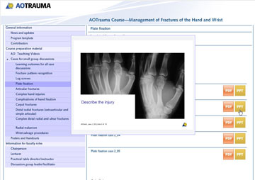

1

2

3

4

Your answer is not correct.

Please try again or press the Solution button.

Incorrect

In a 45–60 minute discussion session, the facilitator should plan to discuss 3 cases (each for around 15 minutes), but have a couple of additional cases available as back-up.

The cases selected should support the learning outcomes that have been set for the session.

**Reference:** "Facilitating small group discussions" booklet p4

Correct

In a 45–60 minute discussion session, the facilitator should plan to discuss 3 cases (each for around 15 minutes), but have a couple of additional cases available as back-up.

The cases selected should support the learning outcomes that have been set for the session.

**Reference:** "Facilitating small group discussions" booklet p4

Solution

4.5 Question 5—Promoting discussion

**Question 5—Promoting discussion**

What techniques for promoting discussion can you spot being used in each of these examples?

Redirecting

"Has anyone else got an answer to Paul´s question?"

"Excellent. I agree­-I think that´s a key point here"

Positive reinforcement

"Why would you choose this treatment first?"

Open question

"What do we call this type of fracture?"

Closed questions

Select the correct option

Closed questions

Redirecting

Positive reinforcement

Open question

Your answer is incorrect.

Please try again or press the Solution button.

Incorrect

The skills required by any discussion facilitator are chiefly those of:

* Skillful use of open and closed questions
* Constructive listening and positive reinforcement of ideas
* Coordination of the group’s efforts, eg, by redirecting questions and by providing summaries

**Reference:** "Facilitating small group discussions" booklet p6

Correct

The skills required by any discussion facilitator are chiefly those of:

* Skillful use of open and closed questions
* Constructive listening and positive reinforcement of ideas
* Coordination of the group’s efforts, eg, by redirecting questions and by providing summaries

**Reference:** "Facilitating small group discussions" booklet p6

Solution

4.6 Question 6—Discussion session closure

**Question 6—Discussion session closure**

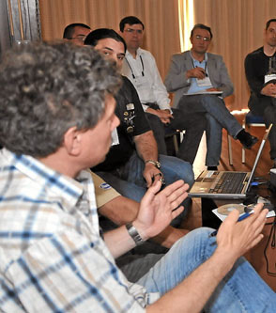What should be included in the session closure?

A pre-prepared summary of key points relating to the case studies

An evaluation by participants of the facilitator's effectiveness

A summary of key points raised through the discussion

A general review of how the discussion went

Your answer is not correct.

Please try again or press the Solution button.

Incorrect

The session closure should always include a summary of key points raised through the discussion—not what you think should have been discussed—so it can be useful for a co-facilitator to keep track of these during the discussion.

If time allows, a general review of how the discussion went may also be useful to help learners think about the skills required for this type of teaching event, but this is not always required. The facilitators should review their own performance after the session—what went well and what should they do differently next time.

**Reference:** "Facilitating small group discussions" booklet p5, 6

Correct

The session closure should always include a summary of key points raised through the discussion—not what you think should have been discussed—so it can be useful for a co-facilitator to keep track of these during the discussion.

If time allows, a general review of how the discussion went may also be useful to help learners think about the skills required for this type of teaching event, but this is not always required. The facilitators should review their own performance after the session—what went well and what should they do differently next time.

**Reference:** "Facilitating small group discussions" booklet p5, 6

Solution

4.7 Question 7— Discussion as a learning tool

**Question 7—Discussion as a learning tool**

Small group discussions include which features that help enrich the learning experience?

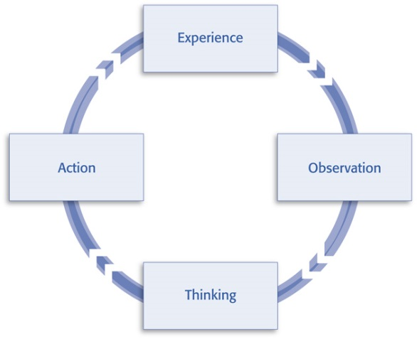The opportunity to change opinions

The presentation of new theories and techniques

An opportunity for reflection

The application of new knowledge to real cases

The use of reasoning and judgement

Kolb learning cycle

Your answer is not correct or only partly correct.

Please try again or press the Solution button.

Incorrect

Discussion groups form a vital part of the mix in AO courses and are especially powerful:

* To encourage reflection (a vital part of the learning cycle)
* To enable learners to use reasoning and judgement—applied to real cases
* To help change attitudes

Lectures and practical sessions are used to present new theories and techniques and to develop "hands-on" psychomotor skills to carry out new procedures.

**Reference:** "Facilitating small group discussions" booklet p3

Correct

Discussion groups form a vital part of the mix in AO courses and are especially powerful:

* To encourage reflection (a vital part of the learning cycle)
* To enable learners to use reasoning and judgement—applied to real cases
* To help change attitudes

Lectures and practical sessions are used to present new theories and techniques and to develop "hands-on" psychomotor skills to carry out new procedures.

**Reference:** "Facilitating small group discussions" booklet p3

Solution

1. Summary

5.1 Facilitating group discussions—Key points and checklists

**Facilitating group discussions—Key points and checklists**

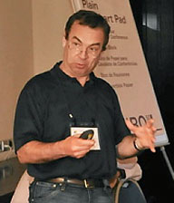**The discussion session**

* The controlled exchange of knowledge, ideas, and opinions on a particular subject
* Allows learners to reflect on what they have learned in other learning events and to use their reasoning and judgement to apply their new knowledge to real cases

**Preparation**

* Plan for a small number of participants (between six and twelve)
* Set appropriate learning outcomes
* Select and prepare cases that are relevant to the course subjects
* Arrange the seating and room so that everyone can see each other and the visual aids
* Plan a clear structure to the session using "Set-Dialogue-Closure"

**The role of the facilitator**

* Communicate expectations and role to learners at the start of the session
* Present the essential information of the cases with initial questions to start off the discussion
* Guide and shape the discussion by using questioning techniques, redirection, reinforcement, and summaries of key learning
* Recognize and respond to different learner types in order to maximize participation
* Close the session by summarizing the main points that were raised during the discussion
* Keep to time!

[Discussion group facilitatoer self assessment](\\\\ao-asif.org\\Duebi\\FilesD\\aoe_duebendorf\\Work\\AOE_Projects\\eLearning_420000\\eModules\\CLX-Stage\\how_to_learn_module\\AOTrauma\\storyboard_module\\module_4\\content\\pdf\\Discussion_group_leader_self_assessment.pdf" \t "_blank)