Storyboard: Running a practical exercise

Struktur:

1. Begin
2. Welcome
   1. Running a practical exercise
   2. Learning outcomes
3. Knowledge check

3.1 Question 1—The function of a practical exercise

3.2 Question 2—Teaching practical skills

3.3 Question 3—Starting the practical exercise

3.4 Question 4—Setting learning outcomes

3.5 Question 5—Chunking the learning

3.6 Question 6—The role of the table instructor

3.7 Question 7—Managing learners

3.8 Question 8—Giving meaningful feedback

1. Summary

4.1 Running a practical exercise – Key points and checklists

1. Begin

**eLearning** Begin

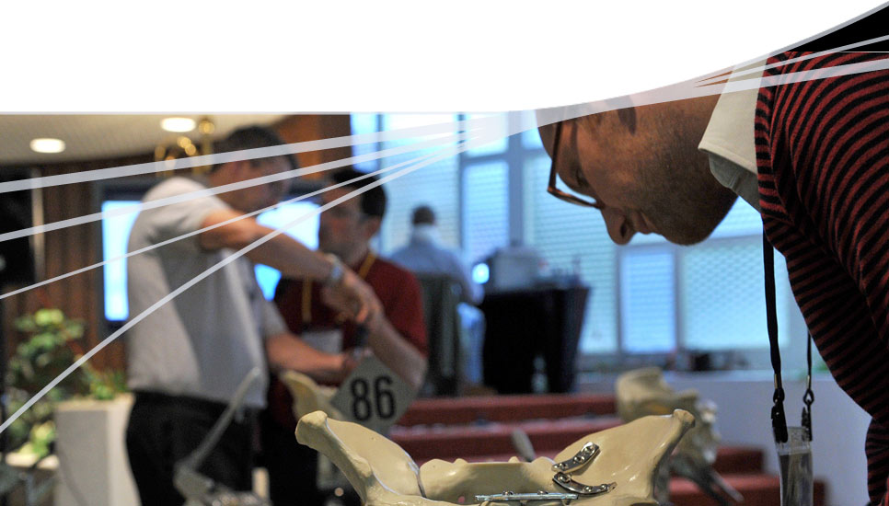**Running a practical exercise**

1. Welcome
   1. Running a practical exercise

**Running a practical exercise**

Welcome to the online knowledge check for module 3—Running a practical exercise.

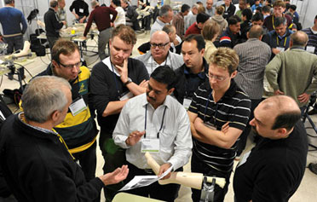This eLearning session is divided into two sections:

* Knowledge check
* Summary
  1. Learning outcomes

**Learning outcomes**

By the end of this module, you should be able to:

* Explain a practical exercise and its function
* Identify the four stages of teaching practical skills
* Describe the rationale for each of the stages
* Set learning outcomes
* Chunk a practical procedure appropriately (CCTV, Video/DVD)
* Manage learning at a practical table
* Deal with different learners

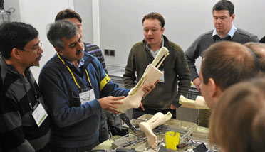

1. Knowledge check

3.1 Question 1—The function of a practical exercise

**Question 1—The function of a practical exercise**



*Start the video and select the correct answer.*

Practice and simulated practical exercises are necessary to develop which domain of learning?

The affective learning domain (attitude)

The psychomotor learning domain (skill)

The cognitive learning domain (knowledge)

Your answer is not correct.

Please try again or press the Solution button.

Incorrect

Practical exercises allow learners to develop psychomotor skills and reinforce their understanding of complex procedures through "hands-on" practice:

* A skill is a complex movement that requires practice
* Feedback, motivation, and practice affect the acquisition of psychomotor skills

**Reference:** "Running a practical exercise" booklet p4

Correct

Practical exercises allow learners to develop psychomotor skills and reinforce their understanding of complex procedures through "hands-on" practice:

* A skill is a complex movement that requires practice
* Feedback, motivation, and practice affect the acquisition of psychomotor skills

**Reference:** "Running a practical exercise" booklet p4

Solution

3.2 Question 2—Teaching practical skills

**Question 2—Teaching practical skills**

During the practical exercise, a four-step approach should be used to teach practical skills.

In which order should you follow these 4 steps?

*Click and drag the options onto the table then click OK.*

Step 1 **Silent demonstration**

Step 2 **Demonstration with explanation**

Step 3 **Learners talks through**

Step 4 **Leaner does**

Your answer is not correct.

Please try again. For the correct answer select the Solution button.

Incorrect

This model highlights the "best-practice" approach for teaching a practical skill allowing the learner to focus on observing, listening, articulating, and finally performing the skill. Step 4 needs to be given the most time as repetition is key to learning psychomotor skills.

**Reference:** "Running a practical exercise" booklet p8, 9

Correct

This model highlights the "best-practice" approach for teaching a practical skill allowing the learner to focus on observing, listening, articulating, and finally performing the skill. Step 4 needs to be given the most time as repetition is key to learning psychomotor skills.

**Reference:** "Running a practical exercise" booklet p8, 9

Solution

3.3 Question 3—Starting the practical exercise

**Question 3—Starting the practical exercise**



When you are ready to start the practical exercise, what should you first show the learners?

The "take-home" message

The first demonstration clip

The materials, tools, and instruments

The "finished result" they are aiming for

How to apply the instruments to the artificial bone

Your answer is not correct or only partly correct.

Please try again or press the Solution button.

Incorrect

Before the demonstration begins, show the learners what tools and instruments they will be using and make sure they know what they are called. Showing the "finished result" is also important so that the learners know what they are aiming for. The "take-home" message should be the last thing that the learners see and hear at the end of the practical exercise session.

**Reference:** "Running a practical exercise" booklet p7

Correct

Before the demonstration begins, show the learners what tools and instruments they will be using and make sure they know what they are called. Showing the "finished result" is also important so that the learners know what they are aiming for. The "take-home" message should be the last thing that the learners see and hear at the end of the practical exercise session.

**Reference:** "Running a practical exercise" booklet p7

Solution

3.4 Question 4—Setting learning outcomes

**Question 4—Setting learning outcomes**

Which of these verbs should be used when setting any learning outcomes and which should be avoided?

|  |  |  |
| --- | --- | --- |
|  | **Verbs to use** | **Verbs to avoid** |
| To understand | **ο** | **ο** |
| To identify | **ο** | **ο** |
| To perform | **ο** | **ο** |
| To be aware | **ο** | **ο** |
| To know | **ο** |  |
| To explain | **ο** | **ο** |

Your answer is not correct or only partly correct.

Please try again or press the Solution button.

Incorrect

Learning outcomes should be expressed from the learner’s point of view—what will they be able **to do** at the end of the practical exercise:

* Use verbs that point to clear actions that are observable and measurable, such as: to write, to identify, to describe, to construct, to demonstrate, to perform
* Avoid verbs that are hard to interpret and measure, such as: to know, to understand, to grasp, to believe

**Reference:**

"Running a practical exercise" booklet p5

Correct

Learning outcomes should be expressed from the learner’s point of view—what will they be able **to do** at the end of the practical exercise:

* Use verbs that point to clear actions that are observable and measurable, such as: to write, to identify, to describe, to construct, to demonstrate, to perform
* Avoid verbs that are hard to interpret and measure, such as: to know, to understand, to grasp, to believe

**Reference:**

"Running a practical exercise" booklet p5

Solution

3.5 Question 5—Chunking the learning

**Question 5—Chunking the learning**

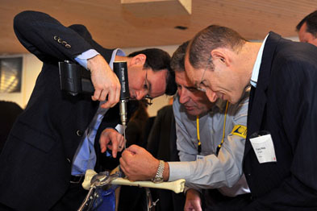How can we define what chunking is?

Using the four-step approach to teaching practical skills

Putting all of the learning into one large exercise

Creating a simulation to enable learners to practice the procedure

Breaking the learning into small components

Your answer is not correct.

Please try again or press the Solution button.

Incorrect

Chunking breaks the learning into short components, each related to a specific skill (expressed as an outcome):

* Identify key steps in each chunk
* Identify appropriate video clips to support the steps in each chunk
* Arrange chunks in logical sequential order

**Reference:** "Running a practical exercise" booklet p7

Correct

Chunking breaks the learning into short components, each related to a specific skill (expressed as an outcome):

* Identify key steps in each chunk
* Identify appropriate video clips to support the steps in each chunk
* Arrange chunks in logical sequential order

**Reference:** "Running a practical exercise" booklet p7

Solution

3.6 Question 6—The role of the table instructor

**Question 6—The role of the table instructor**

What mistakes can you spot being made in each of these pictures?

*Click on the arrow on each box and select an option. Click OK when you have finished.*

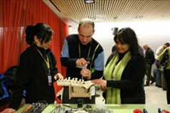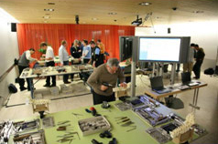

Participant working alone

Table instructor doing exercise

Select the correct option ...

Badly arranged workspace

Participant working alone

Table instructor doing exercise

DVD screen too close to tables

Select the correct option ...

Badly arranged workspace

Participant working alone

Table instructor doing exercise

DVD screen too close to tables

Your answer is not correct.

Please try again or press the Solution button.

Incorrect

The table instructors have an important role in reinforcing the correct procedure and giving feedback. Faculty mistakes **to avoid** include:

* Lecturing at the workstation instead of doing the skill
* Faculty doing the skill instead of letting the participant do the skill
* Disinterested faculty talking on the sidelines, leaving participants alone
* "I don’t use this implant" attitude
* Unfamiliarity with the equipment or instruments
* "Let me show you a better way of doing this than the demo video"

**Reference:** "Running a practical exercise" booklet p10

Correct

The table instructors have an important role in reinforcing the correct procedure and giving feedback. Faculty mistakes **to avoid** include:

* Lecturing at the workstation instead of doing the skill
* Faculty doing the skill instead of letting the participant do the skill
* Disinterested faculty talking on the sidelines, leaving participants alone
* "I don’t use this implant" attitude
* Unfamiliarity with the equipment or instruments
* "Let me show you a better way of doing this than the demo video"

**Reference:** "Running a practical exercise" booklet p10

Solution

3.7 Question 7—Managing learners

**Question 7—Managing learners**

Managing learners with different needs and attitudes is an important component when supporting practical exercises. What tactics might you use to help quiet or anxious learners?

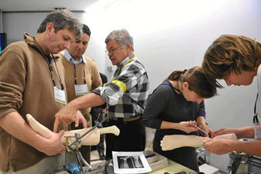Involve them – ask for their help

Give explanations at a slower pace

Search out common ground

Lots of positive reassurance

Ignore them – give them time to settle in

Your answer is not correct or only partly correct.

Please try again or press the Solution button.

Incorrect

Quiet or anxious learners need to be gently drawn out—ask for their help or search out some common ground and give lots of positive reassurance. Try eliciting contributions from them at each stage of the exercise—otherwise you won’t know whether they have understood or not. Slowing down your explanations is only appropriate if it is clear that learners are having difficulty due to language problems or because you are talking too fast.

**Reference:** "Running a practical exercise" booklet p11

Correct

Quiet or anxious learners need to be gently drawn out—ask for their help or search out some common ground and give lots of positive reassurance. Try eliciting contributions from them at each stage of the exercise—otherwise you won’t know whether they have understood or not. Slowing down your explanations is only appropriate if it is clear that learners are having difficulty due to language problems or because you are talking too fast.

**Reference:** "Running a practical exercise" booklet p11

Solution

3.8 Question 8—Giving meaningful feedback

**Question 8—Giving meaningful feedback**



In the four-step approach to giving meaningful feedback, what is the first thing you should do?

Summarize and confirm what the learners should do differently next time

Ask learner what they would do differently next time

Tell learner what went well

Ask learner what went well

Your answer is not correct.

Please try again or press the Solution button.

Incorrect

The four-step approach to feedback brings about a constructive dialogue with the learners:

Step 1—Ask the learner what went well

Step 2—Tell the learner what went well

Step 3—Ask the learner what he/she would do differently next time

Step 4—Summarize and confirm what the learner should do differently next time

**Reference:** "Running a practical exercise" booklet p9

Correct

The four-step approach to feedback brings about a constructive dialogue with the learners:

Step 1—Ask the learner what went well

Step 2—Tell the learner what went well

Step 3—Ask the learner what he/she would do differently next time

Step 4—Summarize and confirm what the learner should do differently next time

**Reference:** "Running a practical exercise" booklet p9

Solution

1. Summary

4.1 Running a practical exercise – Key points and checklists

**Running a practical exercise—Key points and checklist**

**Practical Exercises**

* A structured and interactive activity to enable learners master new, often complex, procedures
* Allow learners to develop and practice psychomotor skills

**Preparation**

* Set meaningful learning outcomes
* Check availability and suitability of materials, equipment and implants
* Review DVD material and plan use of CCTV

**Structuring the practical**

* Plan and structure the session into three sections: Set, dialogue, closure
* Chunk session into small manageable components
* Use the four-step approach to teaching practical skills
* Use the four-step approach to providing meaningful feedback
* Close session with clear summary and a strong "take-home" message

**The role of the table instructor**

* Support learners’ hands-on practice by reinforcing correct procedure and giving constructive feedback
* Use coaching skills to help learners develop themselves
* Keep learners on task and adapt to different learners’ needs

[Table instructor checklist](\\\\ao-asif.org\\Duebi\\FilesD\\aoe_duebendorf\\Work\\AOE_Projects\\eLearning_420000\\eModules\\CLX-Stage\\how_to_learn_module\\AOTrauma\\storyboard_module\\module_3\\content_module_3\\pdf\\Table_Instructor_Checklist.pdf" \t "_blank)